МІНІСТЕРСТВО ОСВІТИ І НАУКИ УКРАЇНИ

УНІВЕРСИТЕТ БАНКІВСЬКОЇ СПРАВИ

Лабораторна робота №7

з дисципліни : Об’єктно-орієнтоване програмування

Виконала студентка

Групи № 106-Кбс

Сорока Олена Олександрівна

КИЇВ 2020

**Lab 7.1.1 Exceptions: input validation**

**Code:**

#include<iostream>

using namespace std;

int main()

{

int a = 8, b, c;

cin >> b;

try

{

if (b == 0)

throw "error";

c = a / b;

}

catch (const std::exception&)

{

cout << "Your input is not valid, you can't divide by zero." << endl;

}

cout << c << endl;

return 0;

}

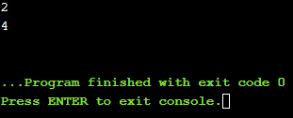

**Lab 7.1.1 Exceptions: divide by zero**

**Code:**

#include<iostream>

using namespace std;

int main()

{

int a, b, c = 0;

cin >> a;

cin >> b;

try

{

if (b == 0)

throw "error";

c = a / b;

}

catch (const exception&)

{

cout << "Your input is not valid, you can't divide by zero." << endl;

}

cout << c << endl;

return 0;

}

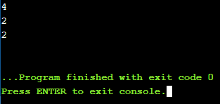

**Lab 7.2.1 Exceptions: input validation**

**Code:**

#include<iostream>

using namespace std;

int main()

{

float r = 0, a, b;

cin >> a;

cin >> b;

try

{

if (b == 0.0)

throw "error";

else

r = a / b;

cout << r << endl;

}

catch (const std::exception&)

{

cout << "Your input is not valid. You can't divide by zero." << endl;

}

return 0;

}

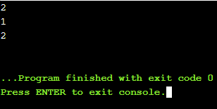

**Lab 7.2.1 Exceptions: catch block**

**Code:**

#include<iostream>

using namespace std;

int square_area(int side)

{

return side * side;

};

int rectangle_area(int side1, int side2)

{

return side1 * side2;

};

int main()

{

float a, b;

cin >> a;

cin >> b;

try

{

if (a < 0 || b < 0)

throw "error";

else

cout << "Square area = " << square_area(a) << "\nRectangle area = " << rectangle_area(a, b) << endl;

}

catch (const exception&)

{

cout << "Your input is not valid. The area can't be negative." << endl;

}

return 0;

}

